

**Submitted To,**Jawad Hossain  
Lecturer  
Department of CSE  
University of Asia Pacific

**Team Member**  
Abidur Rahman Khan (21201191)

Sadman Bin Khorshed Amio (21201201)

Section: D2  
Department: CSE

Course Code: CSE410  
Course Title: Software Development

Project Live Link: <https://abidur191.pythonanywhere.com/>

GitHub Link: <https://github.com/Sb-Amio/BookByte_4.1>

**Project Name:** BookByte (An Online Bookstore Management System)

UNIVERSITY OF ASIA PACIFIC

Table of Contents

|  |  |
| --- | --- |
| No. | Contents |
| 01 | Introduction |
| 02 | Literature Review |
| 03 | System Requirement Specification |
| 04 | System Design |
| 05 | System Implementation |
| 06 | System Architecture and Diagrams a. Use Case Diagram  b. DFD Level 0 c. ER Diagram d. Class Diagram |
| 07 | Team Contributions |
| 08 | User Interface |
| 09 | Testing (Selenium Test) |
| 10 | Future Work |
| 11 | Conclusion |
| 12 | CEP Mapping |

1. Introduction

The world is changing rapidly with the rise of digital technologies, and online platforms have become essential in many areas of life, including education and shopping. Books are a key part of knowledge sharing, but visiting physical bookstores can often be time-consuming or inconvenient for many people. With the aim of solving this problem, we have developed an Online Bookstore Management System using Python and Django. This system helps users easily access a wide range of books, eBooks, accessories, and donated books from the comfort of their home.

The system is designed for two main users: the admin and the customer. Admins can manage all resources such as books, accessories, orders, and donations. They can also edit, remove, or update information at any time, making the platform dynamic and manageable. Customers can browse products, add items to their cart, confirm purchases, and even donate unused or old books through a simple and easy-to-use form. This improves customer interaction and builds a stronger book-sharing community.

The system also includes smart features like a chatbot for real-time suggestions and help. The chatbot answers user queries and helps users find books or understand how to use the site. Another special feature is the book recognition tool, which allows users to upload a cover page of an unknown book. The system then provides the summary and basic details of the book, which is useful for learners, researchers, and general readers who want quick information about a book they come across.

To make the experience smooth and efficient, we focused on building a clean and user-friendly interface. The website is responsive and can be used on both desktop and mobile devices, ensuring easy access for all types of users. Good design and navigation help reduce confusion and improve user satisfaction. We have also focused on security, form validation, and error handling so that users feel safe while using the platform.

The donation feature adds value by allowing people to contribute to the community, especially for students who cannot afford to buy new books. Donated books are listed in a separate section and can be reused by other users, promoting a culture of sharing and extending the life of valuable resources. This feature is not only socially responsible but also supports environmental awareness.

We also added automated testing using Selenium to ensure that the key functions like login and signup work as expected under different scenarios. These tests make the system more reliable, reduce the chance of bugs, and improve the quality of the final product.

This platform promotes the reuse of books and contributes to environmental sustainability by encouraging donations. It also supports learning and literacy by making reading materials more accessible. The project is ideal for educational institutions, startup bookstores, libraries, or individuals planning to sell and share books online. It can be expanded and customized based on future needs, making it a flexible solution for digital book management.

Overall, our goal is to make book purchasing and sharing simple, convenient, and smart through digital transformation. This project not only improves access to books but also creates a positive impact on society by promoting education and community involvement.

2. Literature Review

Before building this project, we studied some existing online bookstore systems and e-commerce platforms such as Amazon, Rokomari, and Daraz. These platforms are widely used and offer a variety of books and other products, but they mainly focus on the selling process. We observed that many platforms focus mostly on selling new books and products, but very few support donating old books or getting book summaries using cover images. This inspired us to think differently and add more social and learning-based features to our project.

We also noted that chat support is not always intelligent or personalized in small-scale platforms. Most of the time, users have to wait for responses or search for answers on their own. In contrast, large platforms use AI-based tools to guide customers smoothly. We realized that even a simple chatbot can greatly improve the experience if it gives quick and relevant suggestions. This understanding motivated us to include a basic chatbot system in our project.

From academic research and technical articles, we learned about the importance of proper database design, clean user interface (UI), and smooth user experience (UX) in web-based platforms. A well-structured database helps in fast data retrieval and easy maintenance. Good UI/UX ensures that users can interact with the website without confusion. We also found that automation, such as auto-generated responses and validation checks, makes systems more reliable and efficient.

Some journal papers highlighted how Django, a Python-based web framework, is ideal for building secure and scalable web applications. Django provides many built-in features such as an admin panel, user authentication, and database ORM (Object-Relational Mapping). These reduce development time and help maintain better code structure. It also supports clean architecture, which is important for large systems.

In our review, we came across systems that offered advanced filtering options, review systems, and personalized suggestions. These features are now considered standard in most e-commerce sites, and we made sure to include similar functionality in our system to make it modern and user-friendly.

We also read about chatbots in customer service. Many studies showed that users feel more satisfied when they receive quick answers through automated chat. A chatbot can also reduce the workload of admins by answering common questions. By applying this knowledge, we developed a simple chatbot in our system to guide users through the platform.

Our system tries to fill the gaps we found in existing systems, especially by adding features like:

* **Donated book management**, which allows customers to share unused books and contribute to the community.
* A **smart chatbot**, which interacts with users and provides help and suggestions.
* **Image-based book information**, where users can upload a book’s cover and get its summary and details.

We used this knowledge as the foundation for our own system, designing a platform that is both innovative and practical. By combining research insights with real-world needs, we aimed to build a system that not only sells books but also encourages learning, sharing, and easy access to knowledge.

3. System Requirement Specification

Our Online Bookstore Management System includes several features to ensure smooth user interaction and effective book management. The system is designed to handle both customer activities and admin responsibilities efficiently. Below is a breakdown of the core functionalities:

**User Management**

* Register: New users can create an account by providing a valid name, email address, and password. The system checks for duplicate emails and validates user input to ensure secure account creation.
* Login: Registered users can log in using their correct email and password. The login system includes basic error handling for incorrect credentials and protects user data.

**Book Management (Admin Side)**

* Add Book: Admins can add new books to the inventory. They need to enter the title, author, price, quantity, category, and a short description. Images of book covers can also be uploaded.
* Update Book: Admins can edit existing book details if there are any changes in price, stock, or book description.
* Delete Book: Admins can remove outdated or unavailable books from the system to keep the inventory clean and up to date.

**Inventory Management**

* View Inventory: Users can browse available books, eBooks, accessories, and donated books. Search and filter options make it easier to find books by category, author, or title.
* Stock Management: The system automatically tracks the stock level of each item. Admins receive alerts when stock is low, helping to manage restocking efficiently.
* Out-of-Stock Handling: If a user tries to order an item that is not in stock, they receive a clear notification, avoiding confusion or failed orders.

**Order Processing**

* Place Order: Customers can add items (books, accessories) to their cart. After selecting the desired quantity, they can confirm the order, which goes into a pending state until admin marks it as delivered.
* E-Book Purchase: Users can also purchase and read eBooks directly from the inventory. These are available for download or viewing online.
* Review System: After receiving a product, users can give reviews, which are stored and displayed in the review section. This helps other buyers make informed decisions.
* Return Product: If a customer receives a faulty or damaged product, they can request a return easily through a form. The admin can verify and accept the return.
* Donate Book: Customers can donate their old or unused books through the donation form. These books are later displayed in a separate “Donated Books” section, encouraging book reuse and community sharing.

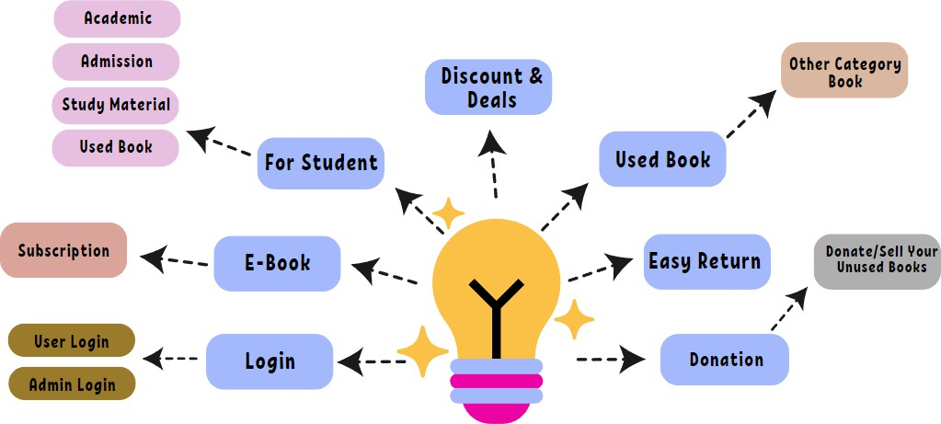

4. System Design

The Online Bookstore Management System has been implemented using the Django framework, which follows the Model-View-Template (MVT) architecture. This design approach helps divide the system’s responsibilities into three parts:

* **Model**: Handles data structure and database interaction.
* **View**: Manages the logic of how data is processed and what should be displayed.
* **Template**: Deals with how the information is shown on the web pages using HTML and CSS.

This separation makes the codebase cleaner, easier to understand, and more maintainable. If any change is needed in the design or logic, it can be done without disturbing the whole system.

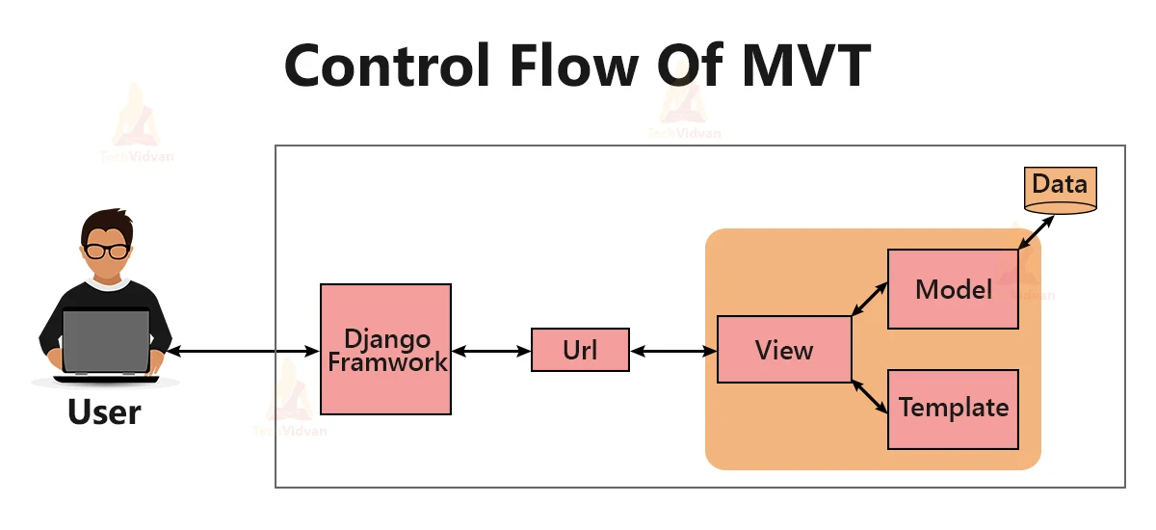

We structured the project into two main panels:

**Admin Panel**

The Admin Panel is used by authorized users who can log in using Django’s default admin authentication system. It provides full control over the entire system:

* Perform CRUD operations (Create, Read, Update, Delete) on all product types including books, eBooks, accessories, and donated books.
* Add new inventory, update book details, or remove outdated products.
* View and manage all customer orders.
* Change the order status (e.g., pending, delivered) and process returns.
* View customer reviews for tracking feedback and improving service.

**Customer Panel**

The Customer Panel is for regular users. Key features include:

* User Registration and Login using custom forms with validation.
* Browsing products like books, eBooks, accessories, and donated books.
* Add items to cart and proceed to checkout.
* Confirm orders by selecting the quantity.
* Donate unused books, which will appear in a separate section for reuse.
* After admin marks an order as delivered, customers can write a review for the purchased product.

We designed our **database models** with proper relationships and foreign key connections to ensure integrity and smooth interaction among data. Below are the key models used:

* **Book / E-Book / Accessory / DonatedBook**: These store information like title, author, price, image, category, and quantity.
* **Cart**: Tracks items added by a user before placing an order.
* **Order**: Holds order information such as items ordered, quantity, total amount, user, and status.
* **Review**: Stores customer feedback and rating related to specific items.
* **UserProfile**: Extends Django’s user model and links each user to their activities like orders, donations, and reviews.

All models are linked using foreign keys, such as:

* Each Order is linked to a User and the corresponding cart items.
* Each Review is linked to the user who wrote it and the item being reviewed.
* UserProfile is connected to Django’s built-in user model using a One-to-One relationship.

**Smart Modules**

We have also implemented two intelligent features to improve user experience:

1. **Chatbot**:
   * Uses keyword matching and simple recommendation logic.
   * Helps users with common queries like “How to donate a book?” or “Where is my order?”
   * Provides suggestions based on user activity or popular items.
   * Reduces the need for manual support and guides the user smoothly through the platform.
2. **Book Recognition System**:
   * Allows users to upload the cover image of an unknown book.
   * The system uses basic image processing and machine learning algorithms to identify the book.
   * Once matched, it displays a summary and other related details of the book.
   * Makes it easier for users to discover and learn more about books they come across physically.

Both features are integrated into the customer interface and are easy to use. These additions make the system more interactive, intelligent, and user-friendly, especially for users who are new to online bookstores.

In summary, the system was carefully implemented with a focus on efficiency, user experience, and data organization. We used Django’s powerful tools and structured coding practices to create a reliable and scalable solution.

5. System Implementation

The implementation of the BookByte (An Online Bookstore Management System) was carried out using a modular, scalable, and maintainable architecture. The development process was driven by the need for robustness, user interactivity, and long-term extensibility. To achieve this, the system was built using Python as the primary programming language, along with the Django web framework, which provided a high-level structure through its Model-View-Template (MVT) design pattern. This separation of concerns allowed for organized development, clear responsibility mapping, and efficient collaboration among team members.

The system architecture was carefully segmented into two primary user-facing components: the Admin Interface and the Customer Interface. This dual-structure ensured that both administrative operations and customer interactions could be optimized without overlap or conflict.

**Backend and Technology Stack**

The backend of the system is the foundation upon which all functionalities were built. Below is a summary of the core technologies and tools used:

**Programming Language:**

The entire backend logic was implemented using Python, a versatile and readable language well-suited for rapid web development.

**Web Framework:**

We used Django, a powerful, high-level Python web framework that encourages clean, pragmatic design. Django’s MVT architecture helped separate concerns efficiently:

* Model: Manages the data and database operations
* View: Handles business logic and acts as a bridge between models and templates
* Template: Responsible for displaying data using HTML/CSS

**Database:**

During development, we utilized SQLite, a lightweight relational database that integrates seamlessly with Django and is ideal for prototyping and small-scale applications. The use of Django’s ORM (Object Relational Mapping) enabled easy interaction with the database without the need for complex SQL queries.

**Authentication:**

User registration and login mechanisms were implemented using Django’s built-in authentication system, which ensures secure password hashing, login validation, and session handling.

**Security Features:**

Several layers of security were integrated:

* CSRF protection (Cross-Site Request Forgery) for form submissions
* Password hashing using Django's default PBKDF2 algorithm
* Input validation to prevent common vulnerabilities such as SQL injection or XSS

**Static Files Management:**

CSS files and image assets were managed using Django’s static files system, ensuring smooth integration with front-end templates and enabling efficient loading and rendering of resources.

**Session Management:**

Django’s session handling system was used to track user login states and maintain the contents of each customer’s shopping cart across different requests.

**Simplification through Django**

The use of Django significantly streamlined the development process:

* The admin interface was rapidly developed with minimal effort by leveraging admin.py, which automatically generates a backend dashboard for all registered models.
* Django’s form classes facilitated robust input validation, reducing the likelihood of faulty data entry.
* The ORM system abstracted database operations, allowing us to manage complex relationships and queries using simple Pythonic syntax, improving productivity and code maintainability.

**Admin Panel Implementation**

The Admin Panel serves as the control center of the system and is accessible only to authorized personnel. It is built on top of Django’s default admin interface, customized as needed to fulfill project requirements. Key features include:

**CRUD Operations:**

Administrators can Create, Read, Update, and Delete records for all major entities including:

* Physical Books
* eBooks
* Accessories
* Donated Books

**Order Management:**

Admins can view a detailed list of customer orders, including:

* Product names
* Quantities purchased
* Customer details
* Order status (e.g., Pending, Delivered)

**Triggering Reviews:**

When an order is marked as Delivered, the system automatically enables the review form for the customer, encouraging post-purchase feedback and promoting trust.

This admin panel provides a secure and powerful backend for inventory management, donation curation, order tracking, and customer interaction logging.

**Customer Panel Implementation**

The Customer Panel was designed with a focus on simplicity, responsiveness, and functionality. It provides customers with a rich, interactive experience that facilitates book discovery, purchase, and sharing. Key customer-side functionalities include:

**User Registration and Login:**

Customers can create accounts and log in using Django’s authentication system. The forms include robust validation to ensure data integrity and security.

**Product Browsing and Filtering:**

Users can browse books, eBooks, accessories, and donated books. Search and filter options based on title, category, or author enable fast content discovery.

**Shopping Cart System:**

* Each authenticated user is assigned a session-based cart.
* Customers can add items, update quantities, and remove products.
* On proceeding to checkout, the system generates an order record and assigns it a status of Pending.

**Book Donation Form:**

Customers can contribute unused books via a structured form. They submit key details (title, author, condition, etc.), and upon admin approval, the item is displayed in the “Donated Books” section.

**Review System:**

Customers are encouraged to provide feedback and rate items after receiving them. This enhances transparency and supports other users in making informed purchasing decisions.

**Smart Feature Integration**

To distinguish our platform and offer value beyond standard e-commerce functionality, we integrated two intelligent modules:

**Book Summary from Cover Image**

This module allows users to discover details about unknown books by simply uploading an image of the cover.

**Implementation Steps:**

* Users upload a book cover image via the frontend.
* The system employs Optical Character Recognition (OCR) to extract relevant text (e.g., title, author).
* It then searches the internal database for matches.
* Upon a successful match, the book's summary, author biography, and genre details are displayed to the user.

This feature assists students, researchers, and casual readers in instantly identifying physical books they come across in libraries or public spaces.

**Chatbot Assistant**

The chatbot is a rule-based system written in Python, designed to respond to frequently asked questions and guide users.

**Functionality Includes:**

* Responding to product inquiries: “What kind of books are available?”
* Assisting with navigation:

“How can I donate a book?”

* Offering personalized suggestions:

“What are the top-rated items?”

Although not AI-driven, the chatbot significantly reduces dependency on human support and provides real-time guidance, especially useful for new users.

**Design Flow Summary**

To ensure that all components of the system work harmoniously, the following design flow was maintained:

**Frontend (Template Layer):**

Users interact with the system via HTML-based templates styled with CSS. Responsive design principles ensure accessibility across devices.

**Backend (View Layer):**

User requests are routed through Django views, which process the data, apply logic, and determine the correct response.

**Model Layer:**

Data is fetched from or stored into the SQLite database via Django models and the ORM.

**Admin and Customer Interfaces:**

Clearly separated to prevent unauthorized access and allow role-specific functionalities.

**Integration of Smart Features:**

Chatbot and image-based book summary tools are embedded within the customer panel, providing enhanced interactivity.

6. System Architecture and Diagrams

In this section, we present the major system design diagrams that were used to plan, structure, and visualize different parts of the Online Bookstore Management System. These diagrams helped us understand the system’s workflow, data structure, user interactions, and database relationships before writing any code. Each diagram plays an important role in different phases of development, ensuring a smooth transition from design to implementation. By using these diagrams, we were able to reduce confusion, divide tasks more effectively, and maintain consistency throughout the project. The diagrams also helped in identifying key modules, dependencies, and user roles early in the development process.

The Use Case Diagram helped us identify the various actions users can perform, such as browsing books, placing orders, donating books, or managing resources as an admin. It gave a clear idea of what functionalities need to be implemented for each type of user.

The Class Diagram allowed us to map out all classes (models) in the system and how they are related. This was essential for Django development since our models are at the core of the backend logic.

The Data Flow Diagram (DFD**)** illustrated the movement of data between processes and how different parts of the system communicate with one another. It ensured that the system maintains data accuracy and handles user inputs correctly.

The Entity Relationship (ER) Diagram was used to plan the structure of our database. It shows how entities such as books, users, orders, and reviews are linked together, helping us design efficient and normalized database tables.

Together, these diagrams formed the blueprint of our system, guiding us through both the frontend and backend development. They also made it easier to explain the system design during presentations or team discussions.

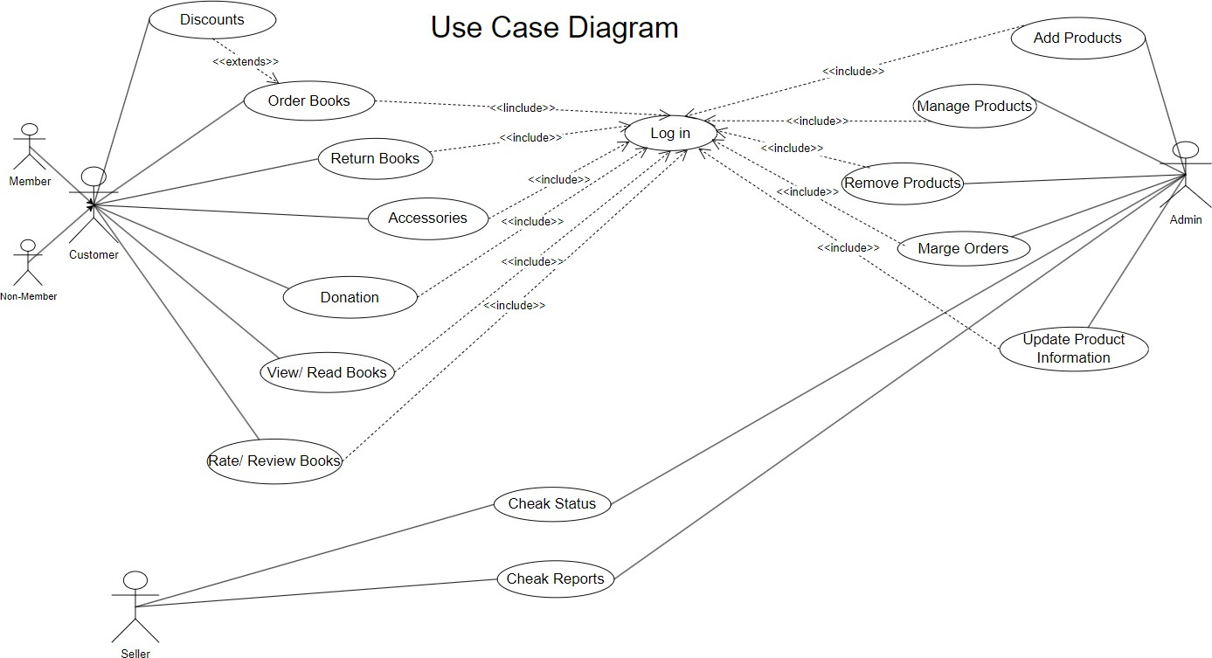

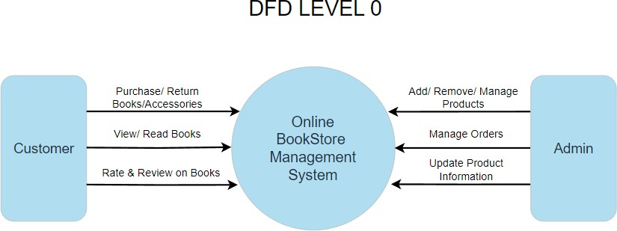

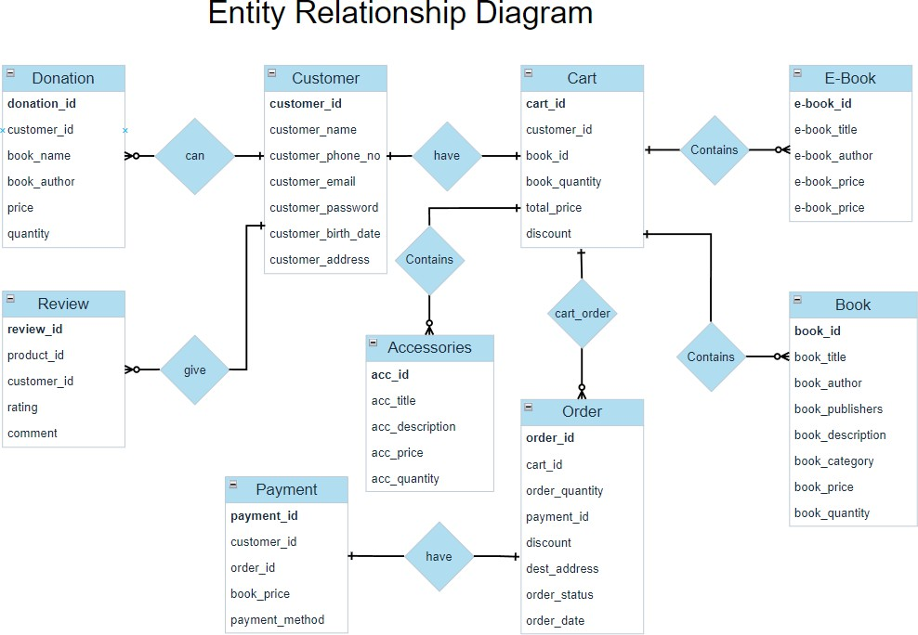

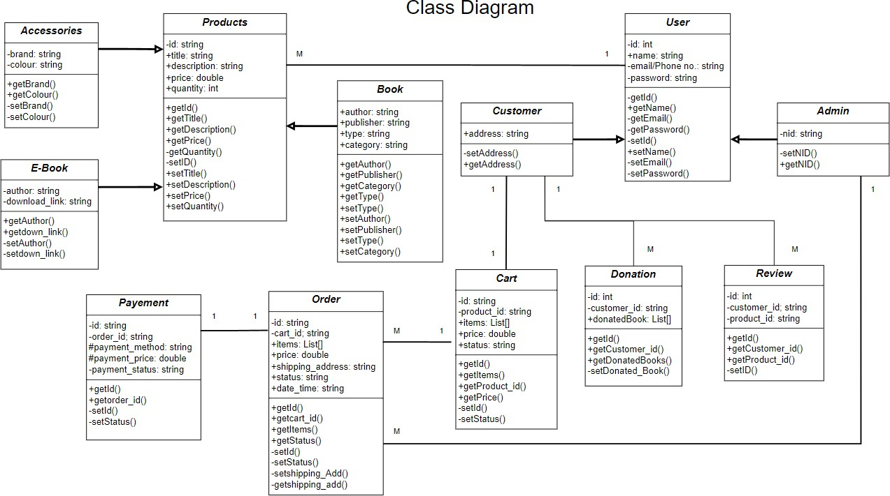

7. Team Contributions

This project was completed through strong teamwork and collaboration, where each member played a crucial role in ensuring the successful development and implementation of the Online Bookstore Management System. While each member had specific responsibilities, we often assisted each other in overlapping areas, which enabled us to learn from one another and maintain a steady development pace. Through continuous communication and support, we were able to overcome challenges and meet deadlines efficiently.

**Member 1: Sadman Bin Khorshed Amio**

Primarily responsible for developing the customer-side of the system and ensuring that users had an engaging and smooth experience. The contributions were as follows:

* **Customer Interface Development:** Designed and developed the entire front-end of the customer panel, including layout, design, and navigation. Ensured the platform was easy to use and intuitive for end-users.
* **Product Browsing System:** Implemented features that allow customers to browse books, eBooks, accessories, and donated books by category, author, and other filters. This made the platform dynamic and easy to explore.
* **Add to Cart and Order Confirmation System:** Created the cart system where users could add items, adjust quantities, and proceed to checkout. Also ensured smooth order confirmation and payment process integration.
* **Book Donation Feature:** Developed a donation form where customers can submit details of their old books to donate. This unique feature promotes sustainability and supports community engagement.
* **Review System:** Built the review and rating system, allowing customers to provide feedback and rate books after they have been delivered. This feature helped improve customer engagement and trust in the platform.
* **Chatbot Integration:** Integrated a chatbot to assist customers with quick answers to their queries. This AI-based feature provides book recommendations and answers questions about genres, pricing, and availability.
* **Book Summary from Cover Image:** Integrate the feature where users can upload a book cover image, and the system uses image recognition and matching to provide a summary and additional information about the book.
* **Responsive Design:** Focused on creating a responsive and user-friendly design to ensure that the customer experience is seamless across different devices (desktops, tablets, smartphones).
* **Testing and Debugging:** Collaborated with the team to test the customer-side functionalities, identifying bugs and issues, and working together to resolve them quickly. Also contributed to the testing of the overall customer flow to make sure all user interactions were smooth and intuitive.

**Member 2: Abidur Rahman Khan**

Took the lead in developing the admin-side of the system, ensuring that admins had the necessary tools to manage the platform and customer activities effectively. Contributions included:

* **Admin Interface Development:** Developed the entire admin interface using Django Admin. Customized the admin dashboard for better usability and ensured it was capable of handling complex tasks related to resource management.
* **CRUD Operations:** Implemented all the CRUD operations (Create, Read, Update, Delete) for books, eBooks, accessories, and donated books. Ensured that admins could easily manage inventory and add or update product details.
* **Order Tracking and Management:** Created the order management system, allowing admins to view all placed orders, update order status from "pending" to "delivered", and track customer orders effectively. This feature helped the admin maintain an organized record of transactions.
* **Database Management:** Managed the database structure, ensuring correct relationships between various models such as books, eBooks, accessories, orders, and users. Also handled database migrations and optimized queries for performance.
* **Form Handling and Validations:** Implemented backend form handling, ensuring that input data was validated and stored correctly in the database. Admin-side forms for book additions, updates, and inventory management were thoroughly tested for correctness.
* **System Security and Authentication:** Ensured that only authorized users could access the admin panel by implementing a secure login system. Also worked on setting up roles and permissions within the admin interface to control access to sensitive data.
* **Admin Testing:** Participated in system testing, particularly focusing on the admin-side features, ensuring that all CRUD operations, order tracking, and content management functions were working smoothly. Also reviewed the admin dashboard for usability improvements.
* **Collaborative Troubleshooting:** Actively collaborated with the team to troubleshoot and resolve issues related to the integration of both admin and customer sides, ensuring that both panels were aligned and the data flow was consistent between them.

8. User Interface

The user interface (UI) of our Online Bookstore Management System is designed to be clean, user-friendly, and responsive. It provides a smooth experience for both customers and administrators. The customer site includes easy navigation menus, search options, a cart system, and interactive features like book donation, chatbot support, and book summary generation from uploaded cover images. On the other hand, the admin panel offers a structured and efficient way to manage all site content including books, accessories, donations, and orders.

In this section, we have included screenshots of different pages such as the homepage, book listing, cart page, donation form, chatbot interface, and the admin dashboard. These screenshots represent the final outcome of our project and give a visual idea of how the system works in real-time. The design focuses on simplicity, clarity, and usability to ensure that users can complete their tasks with ease.

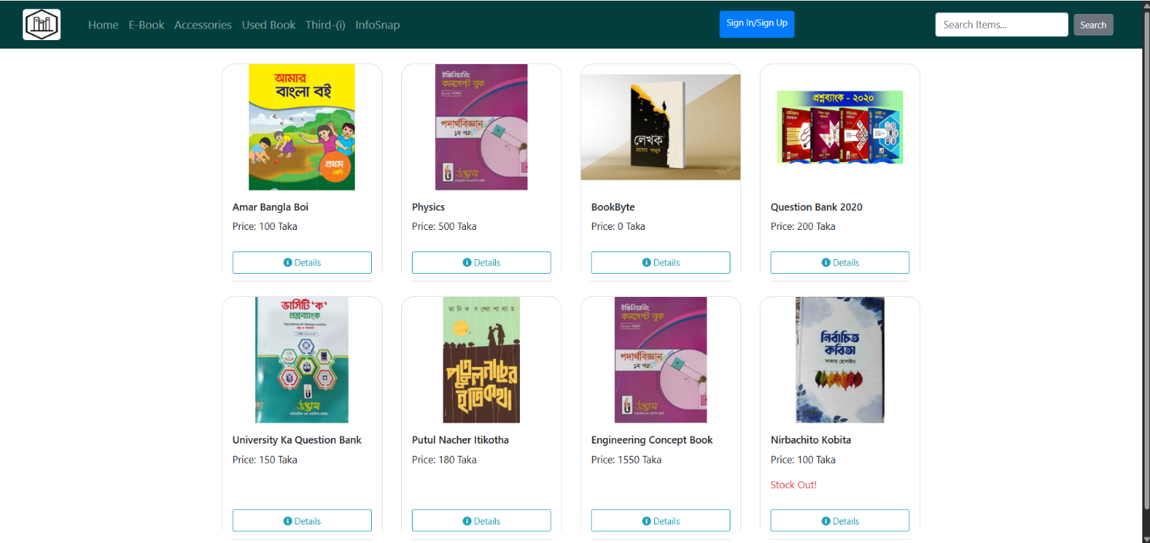Landing Page

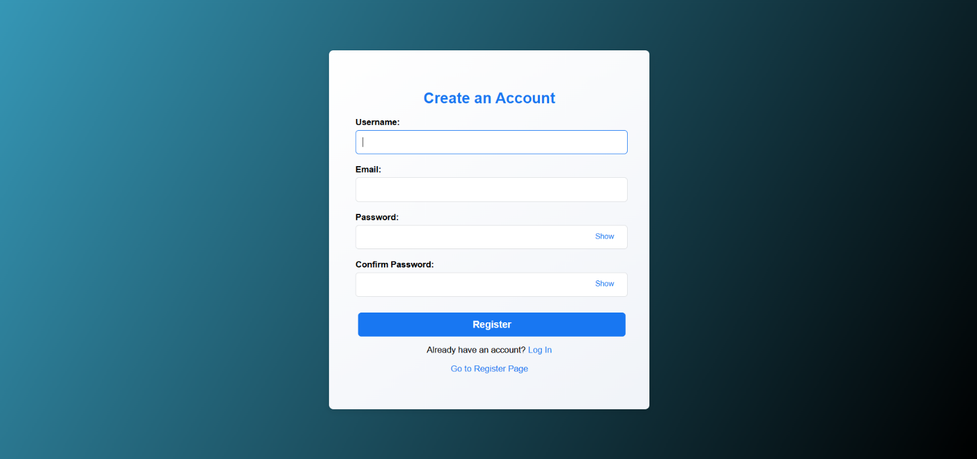Registration Page

Login Page

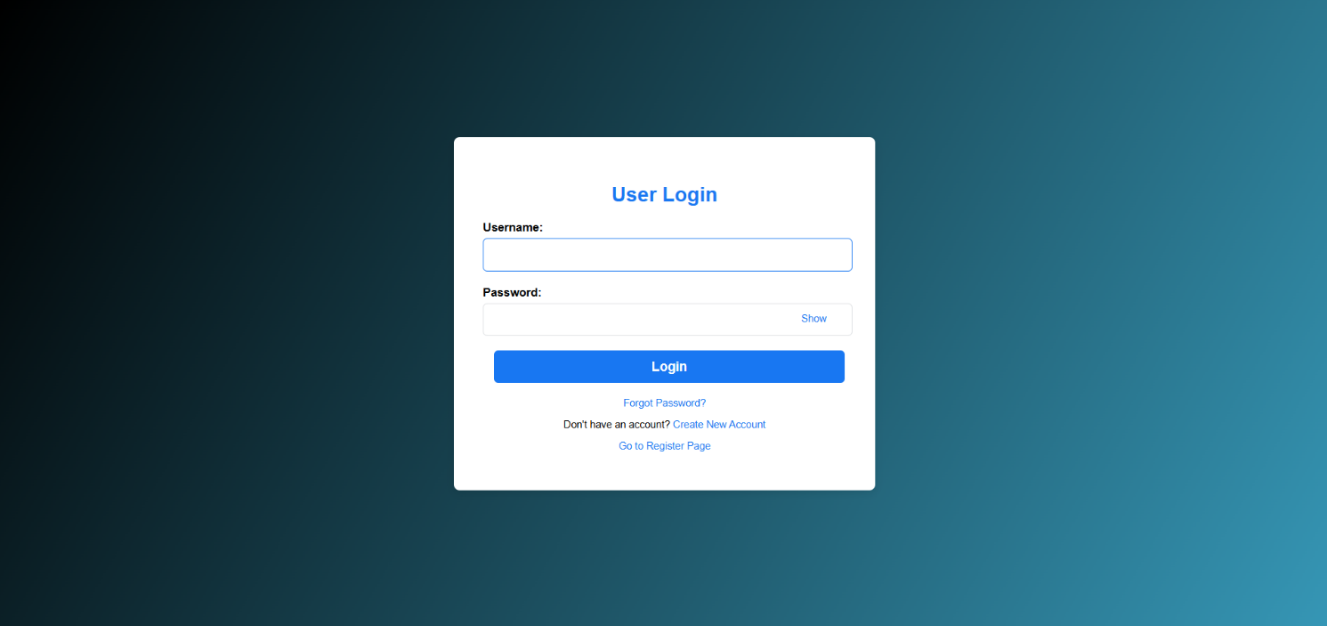

Customer Home Page

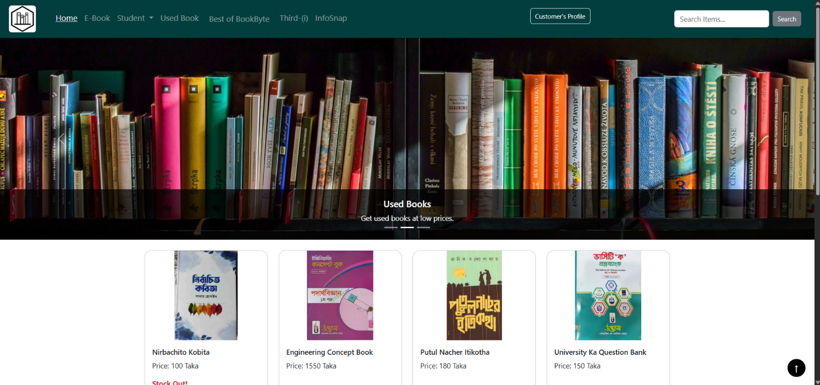

Book Details View Page

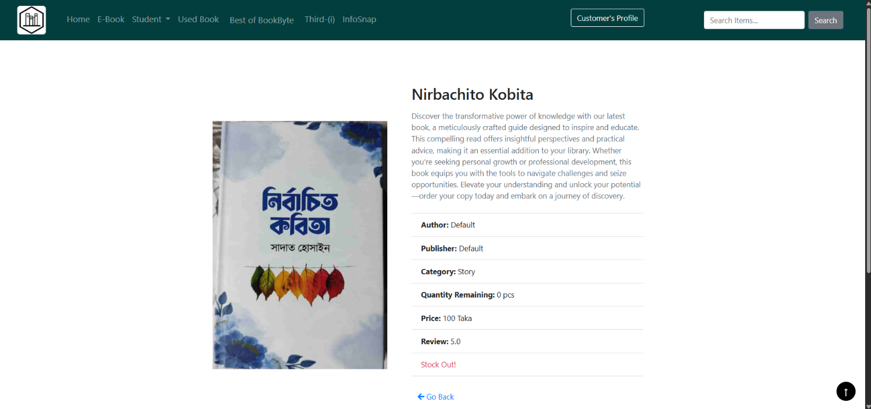

Customer E-book View Page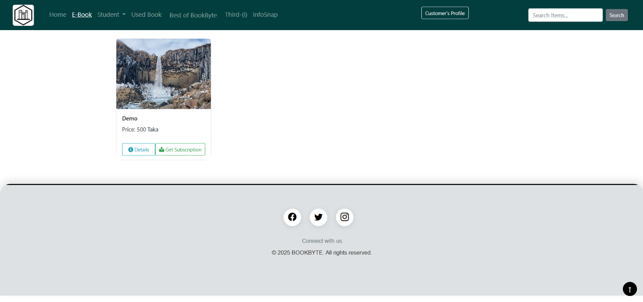

Customer Accessories View Page

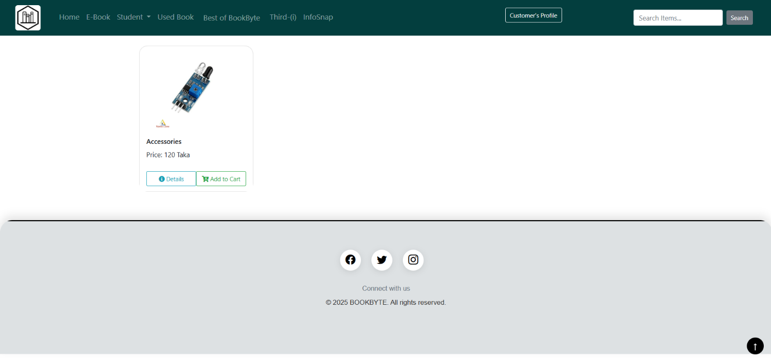

Customer Used Book View Page

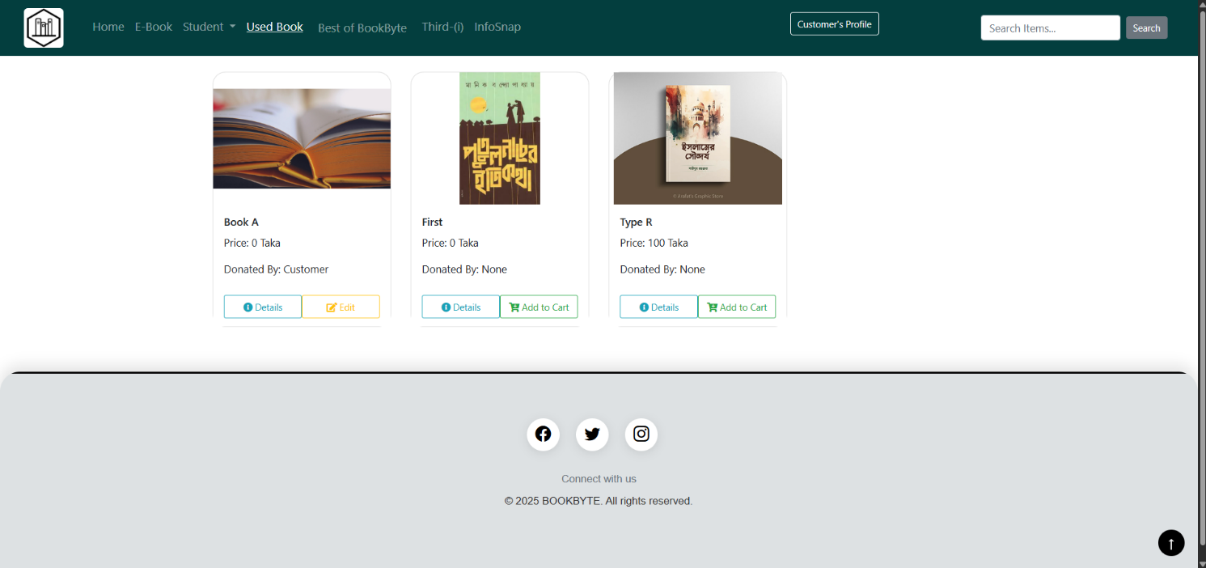

Customer Recommendation Book View Page

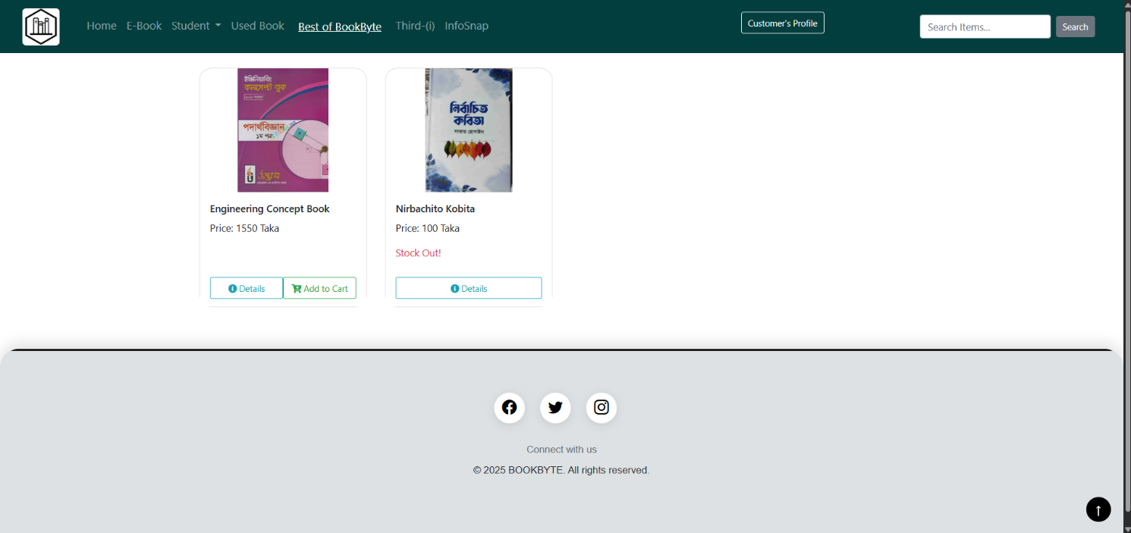

Chatbot Chat Interface

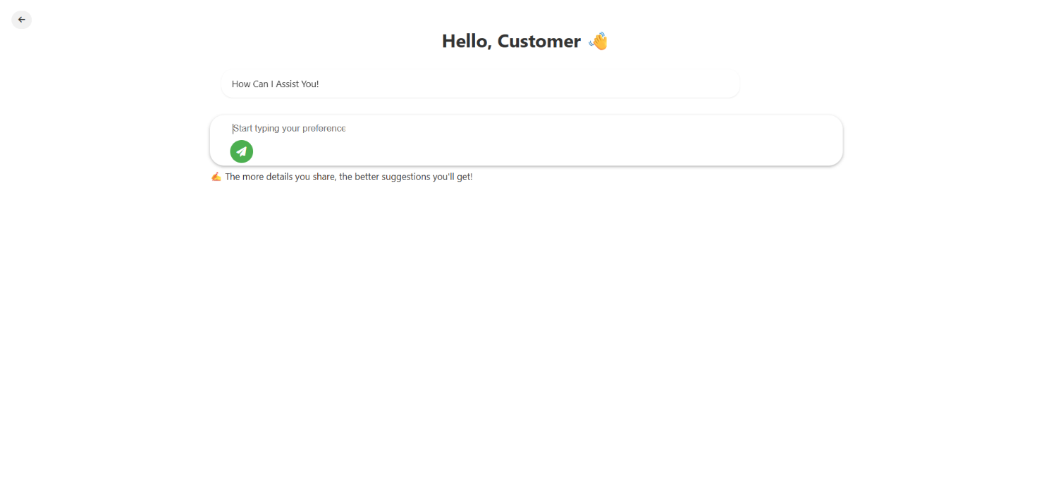

Find Book Information Using Cover page Interface

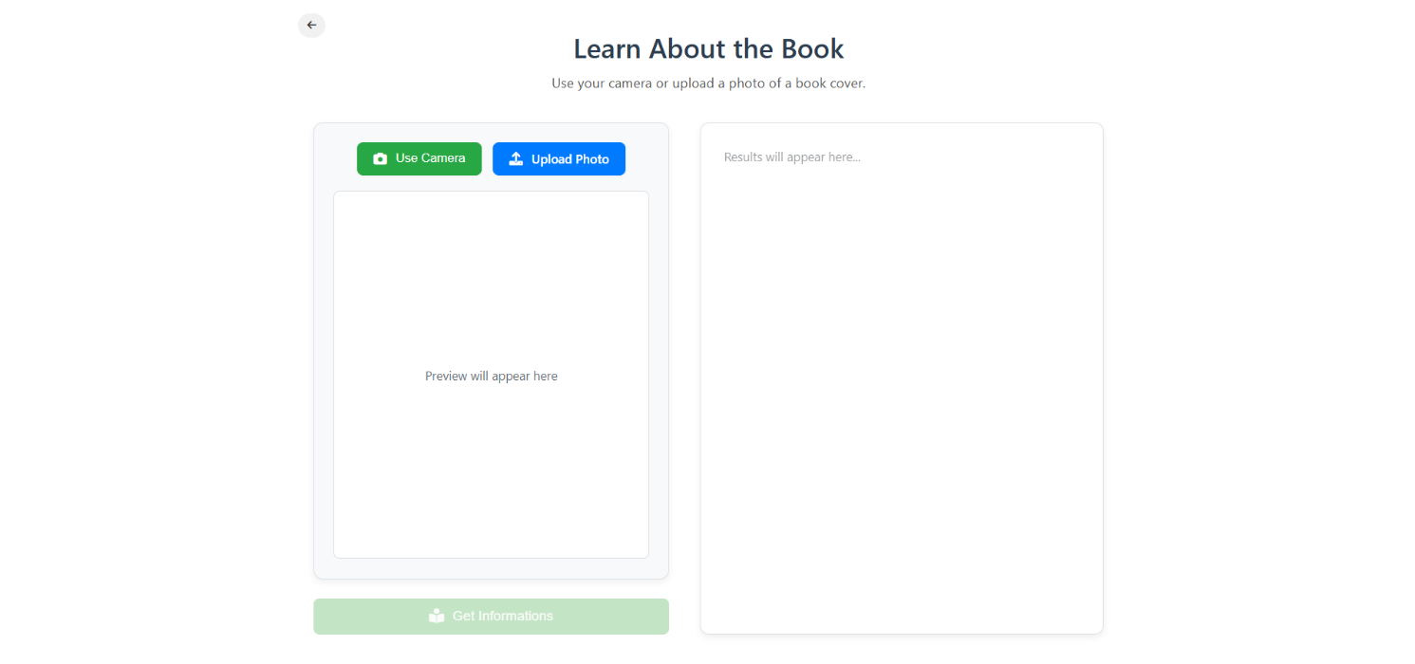

Customer My Cart View Page

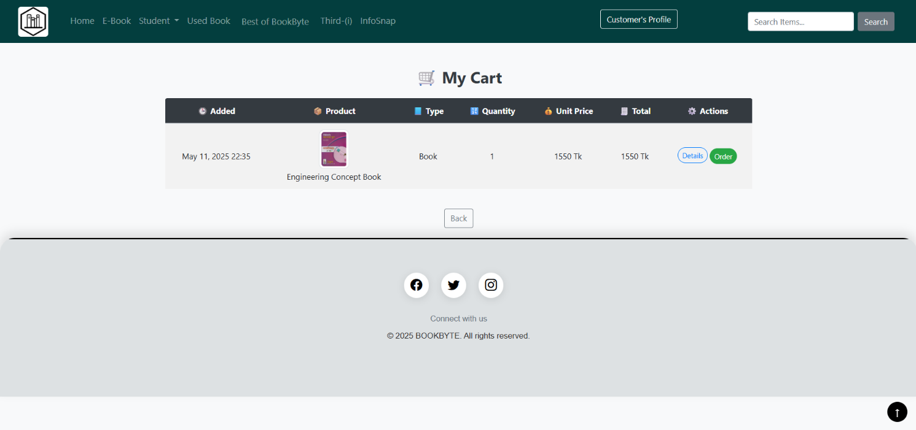

Customer My Order View Page

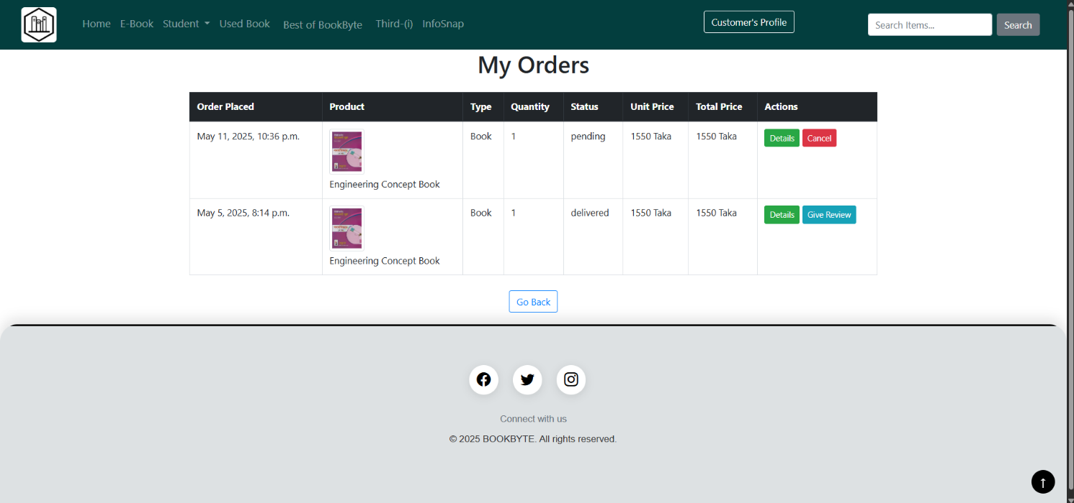

Customer My Review View Page

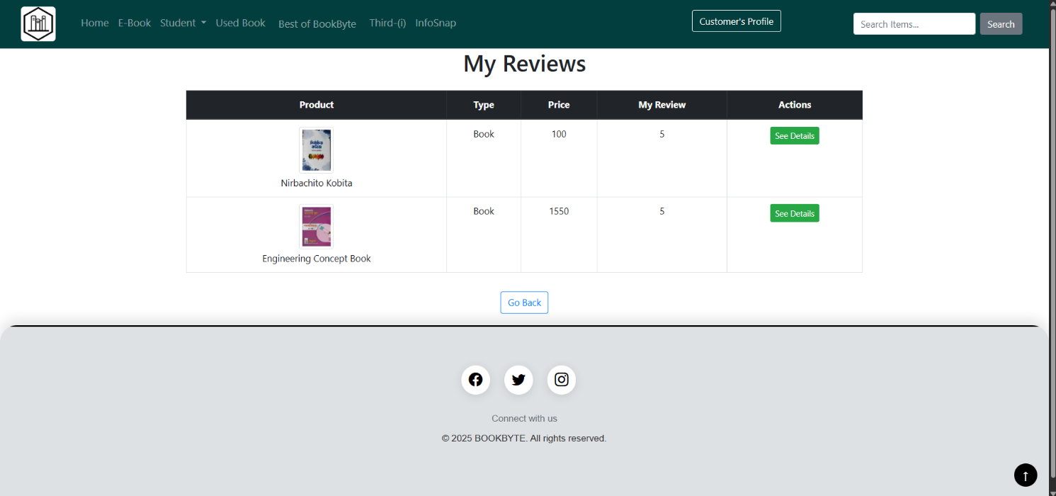

Customer Used Book Upload Form Page

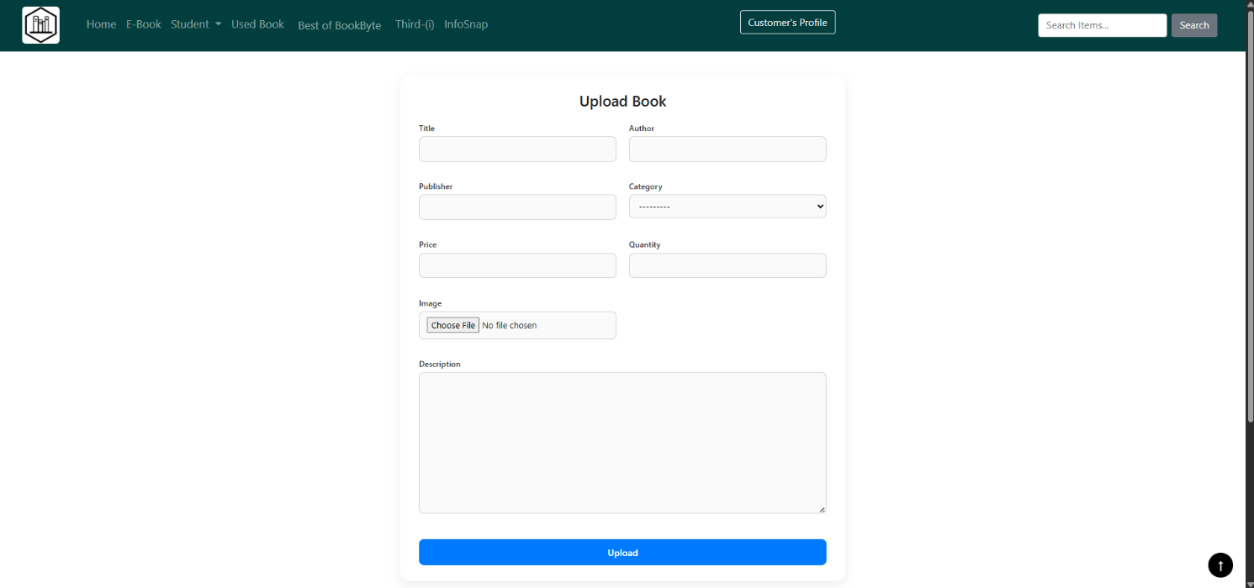

Customer Search Query Result View Page

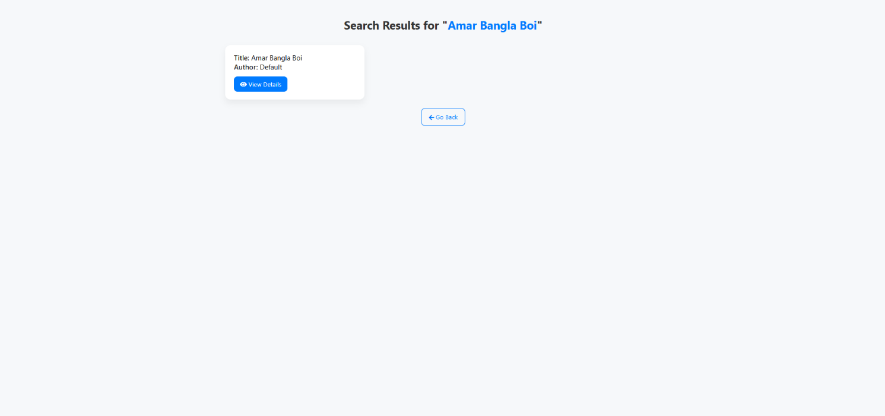

Admin Home Page

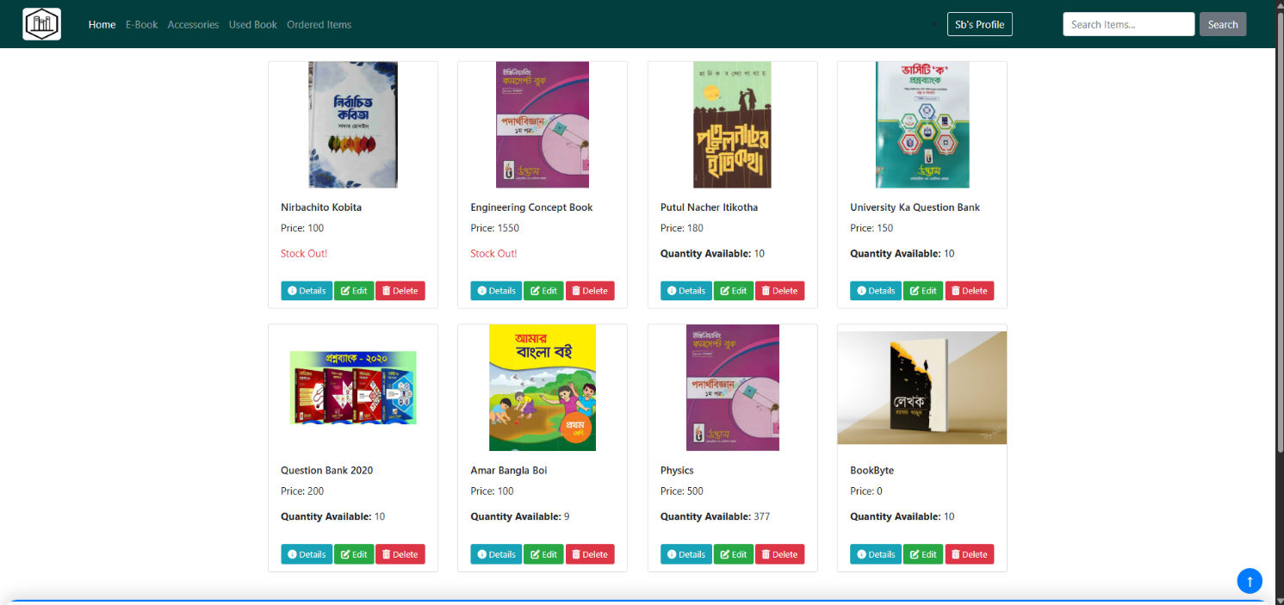

Admin Item Edit Form View Page

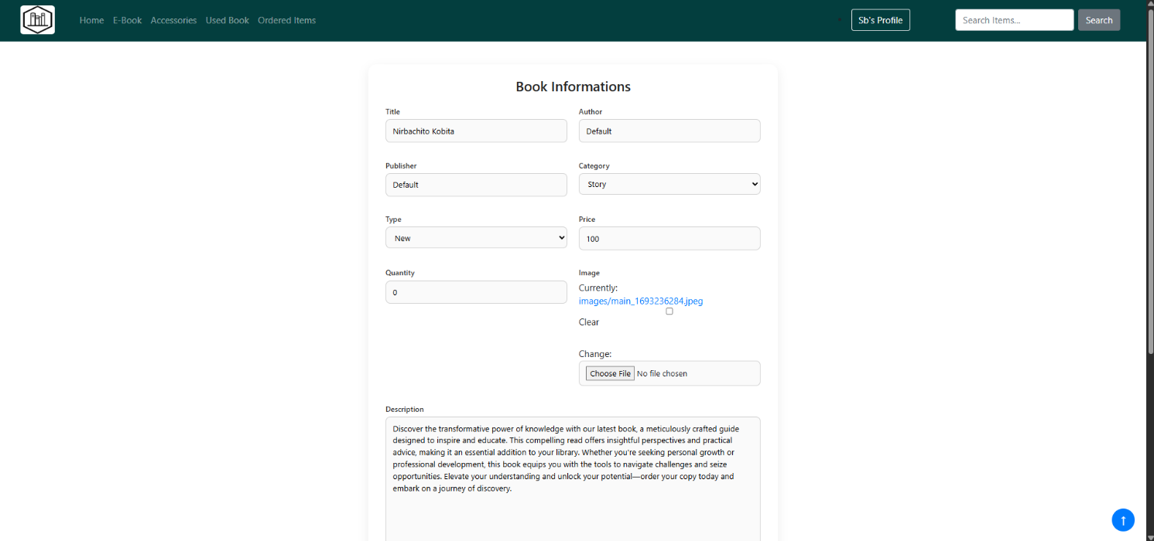

Admin Item Delete Page

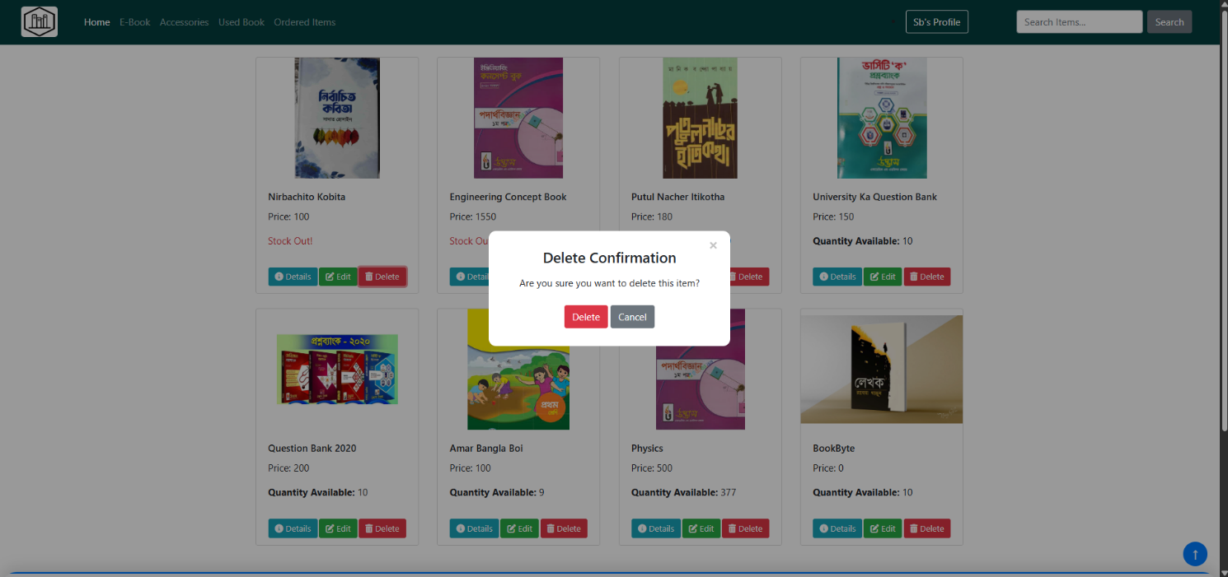

Admin Order Track View Page

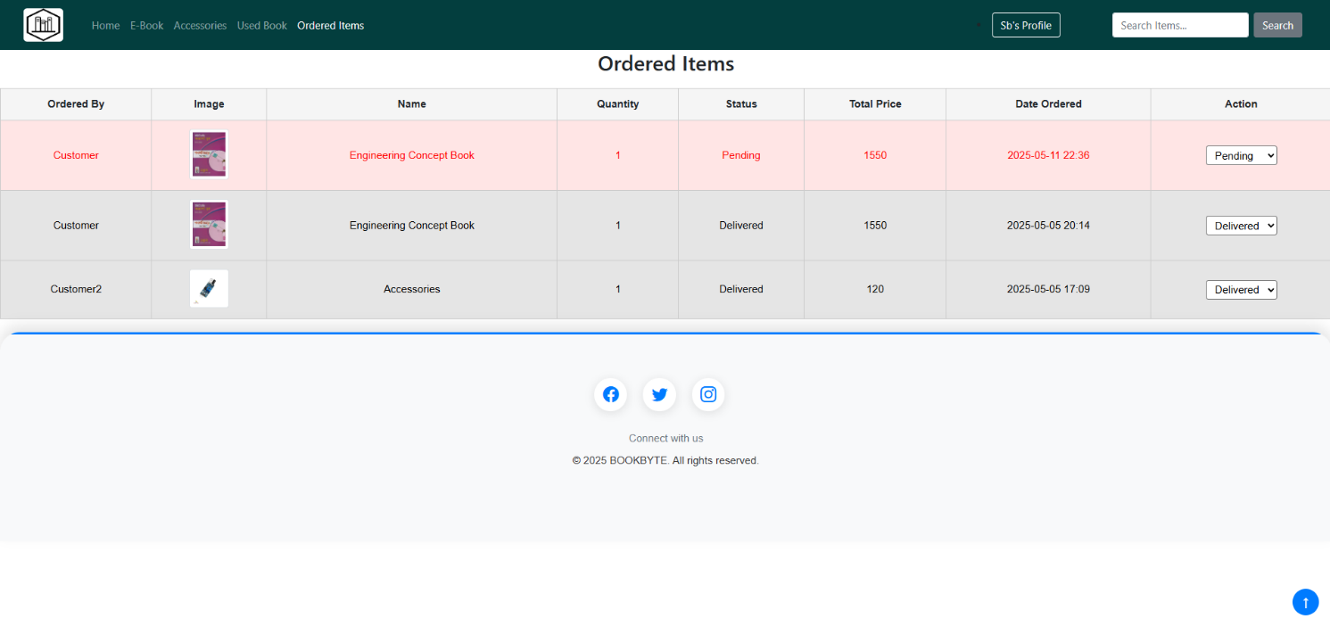

Admin Add Book Form Page

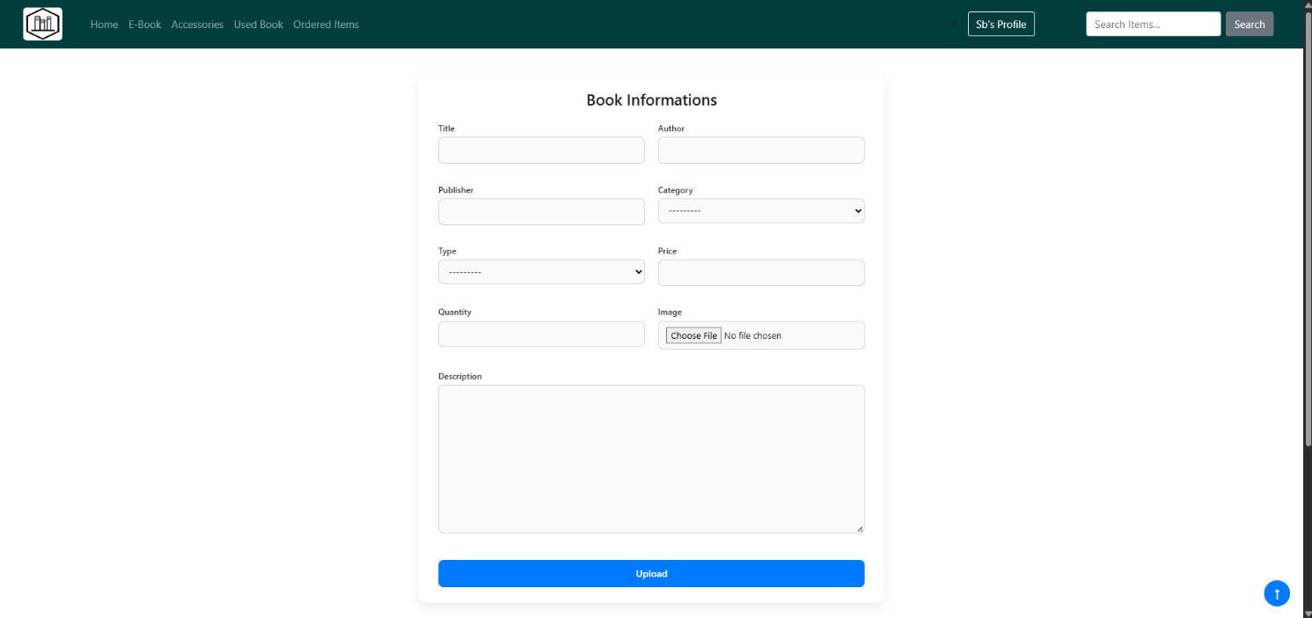

Admin Add E-Book Form Page

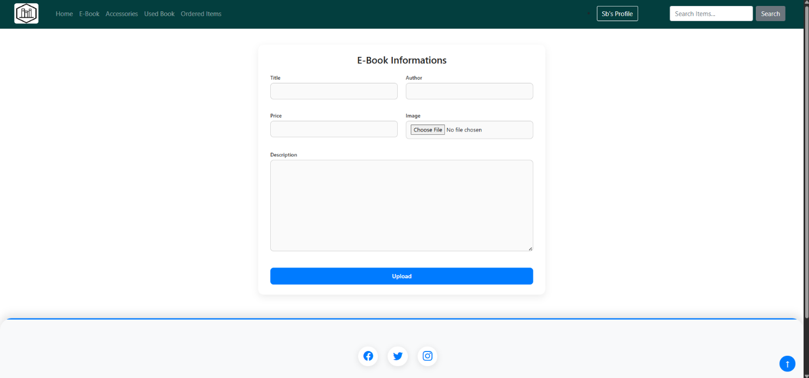

Admin Add Accessories Form Page

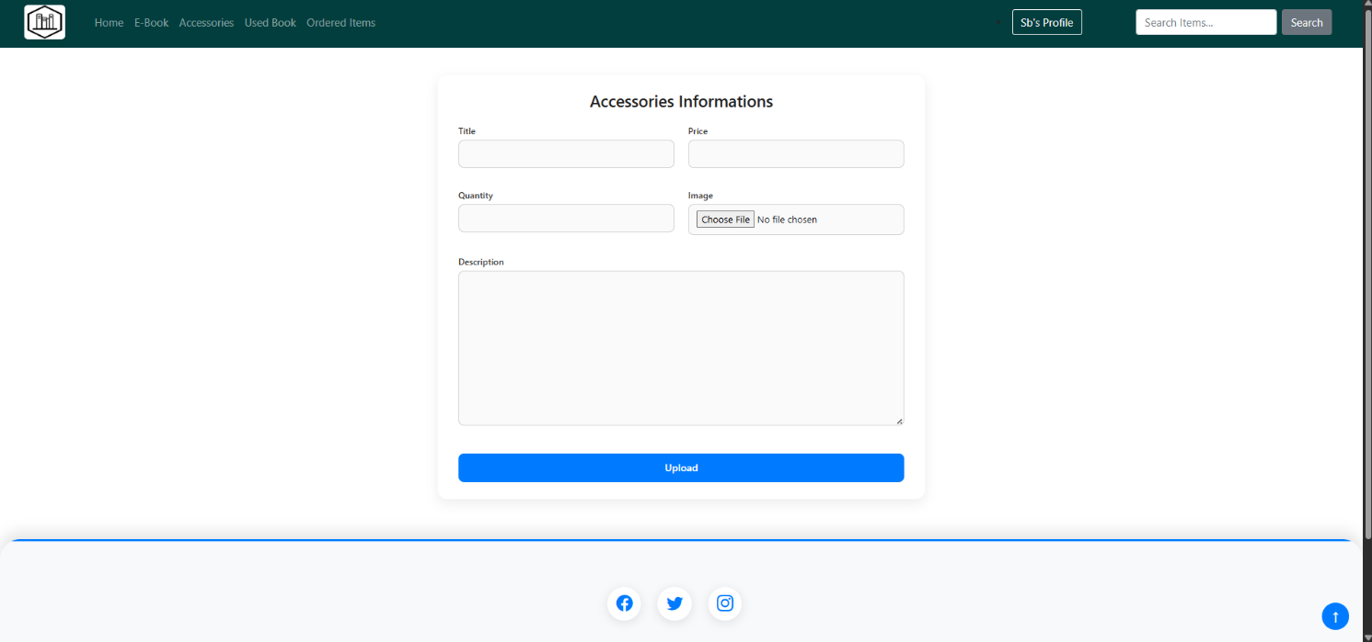

Admin E-Book View Page

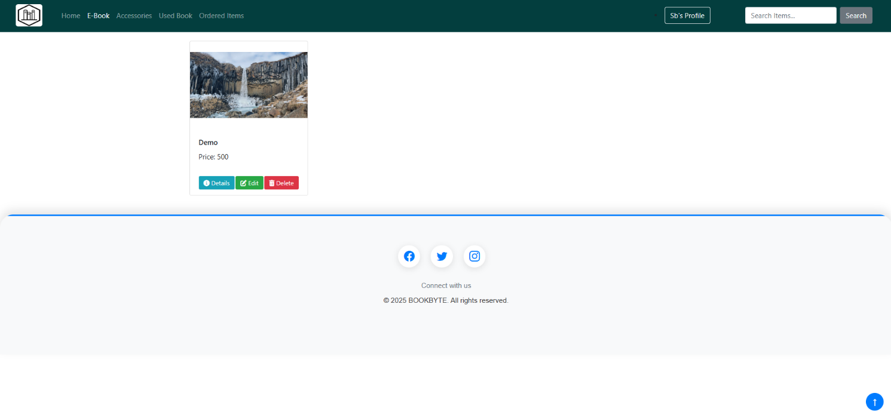

Admin Accessories View Page

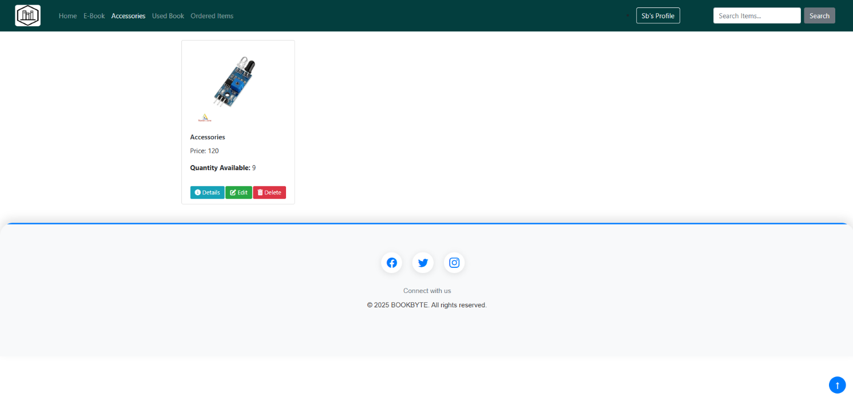

Admin Donated Book View Page

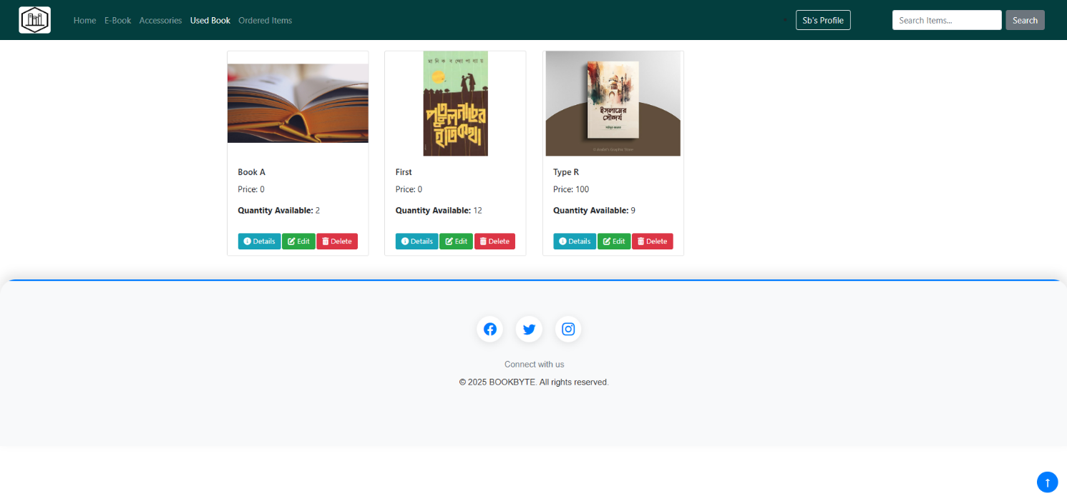

9. Testing (Selenium Test)

To ensure that our Online Bookstore Management System functions correctly and without errors, we leveraged **Selenium** for automated testing. Selenium is a widely-used and robust tool designed for testing web applications by simulating real user interactions with a browser. This tool enabled us to run tests efficiently and ensure that key features of our system, particularly user authentication, were working as intended.

**Login Page Testing**

For the Login Page, we ran several tests to ensure users can log in successfully with valid credentials and handle invalid login attempts correctly. The key tests we conducted were:

* Successful Login: We verified that registered users can log in by providing the correct username (email) and password. The system should allow users to enter their accounts and redirect them to the correct homepage or dashboard.
* Invalid Login Attempts: We tested the login page under various failure conditions, such as:
  + Entering an incorrect password for a valid username.
  + Providing an invalid username.
  + Leaving one or both fields blank.

In each case, the system should display an appropriate error message (e.g., "Invalid username or password"), ensuring the user knows what went wrong.

* Error Message Validation: We also made sure that error messages were displayed in the right format and in the correct position, making it clear to the user why their login attempt failed.

Login Page Test Code

import pytest

import time

from selenium import webdriver

from selenium.webdriver import Keys

from selenium.webdriver.chrome.service import Service as ChromeService

from selenium.webdriver.common.by import By

from webdriver_manager.chrome import ChromeDriverManager

@pytest.fixture()

def driver():

    driver = webdriver.Chrome(service=ChromeService(ChromeDriverManager().install()))

    driver.implicitly_wait(10)

    yield driver

    driver.quit()

@pytest.mark.parametrize("username, password", [

    ("Customer", "abcdabcd"),

    ("Customer", "wrong"),

    ("Anonymous", "abcdabcd"),

    ("Anonymous", "wrong"),

    ("Sb", "abcdabcd"),

])

def test_login(driver, username, password):

    driver.get("http://127.0.0.1:8000/login_user/")

    username_field = driver.find_element(By.ID, "id_username")

    password_field = driver.find_element(By.ID, "id_password")

    submit_button = driver.find_element(By.CSS_SELECTOR, "button")

    username_field.send_keys(username)

    password_field.send_keys(password)

    submit_button.click()

    time.sleep(1)

    #print(driver.page_source)

    # Assert based on actual success criteria

    #assert "Dashboard" in driver.page_source  # Replace with the actual success indicator

Login Page Test Result

|  |  |  |  |  |  |
| --- | --- | --- | --- | --- | --- |
| **Test Case No.** | **Username** | **Password** | **Expected Result** | **Actual Result** | **Status** |
| 1 | Correct | Correct | Login Successful | Login Successful | Passed |
| 2 | Incorrect | Correct | Login Failed (Error Msg) | Login Failed (Error Msg) | Passed |
| 3 | Correct | Incorrect | Login Failed (Error Msg) | Login Failed (Error Msg) | Passed |
| 4 | Incorrect | Incorrect | Login Failed (Error Msg) | Login Failed (Error Msg) | Passed |

**Signup Page Testing**

For the Signup Page, we focused on ensuring that new users could successfully register by filling out all the required fields. The primary goal was to test the system's ability to handle valid and invalid data inputs. Our tests included:

* Valid Registration: We tested the process where a user enters valid information (name, email, and password), ensuring the form accepts the data, creates a new user account, and redirects the user to the appropriate page (such as the login or home page).
* Field Validation: We ensured that the system properly validates input fields, checking for correct formatting of email addresses and passwords, as well as confirming that the passwords match (Password1 and Password2).
* Error Handling: We tested what happens when a user provides invalid data, such as an email in an incorrect format, missing fields, or mismatched passwords. We verified that appropriate error messages were displayed, guiding the user to correct their inputs.

Sign Up Page Test Code

import pytest

import time

from selenium import webdriver

from selenium.webdriver import Keys

from selenium.webdriver.chrome.service import Service as ChromeService

from selenium.webdriver.common.by import By

from webdriver_manager.chrome import ChromeDriverManager

@pytest.fixture()

def driver():

    driver = webdriver.Chrome(service=ChromeService(ChromeDriverManager().install()))

    driver.implicitly_wait(10)

    yield driver

    driver.quit()

@pytest.mark.parametrize("username, em, password1, password2", [

    ("CustomerTest","21201201@uap-bd.edu", "abcdabcd", "abcdabcd"),

    ("CustomerTest", "wrong", "abcdabcd", "abcdabcd"),

    ("Customer Test", "21201201@uap-bd.edu", "abcdabcd", "abcdabcd"),

    ("Customer Test", "21201201@uap-bd.edu", "abcdabc", "abcdabcd"),

    ("Customer_Test", "21201201@uap-bd.edu", "wrong", "wrong"),

])

def test_login(driver, username,em, password1, password2):

    driver.get("http://127.0.0.1:8000/register/customer2")

    username_field = driver.find_element(By.ID, "id_username")

    email_field = driver.find_element(By.ID, "id_email")

    password_field1 = driver.find_element(By.ID, "id_password1")

    password_field2 = driver.find_element(By.ID, "id_password2")

    submit_button = driver.find_element(By.CSS_SELECTOR, "button")

    username_field.send_keys(username)

    email_field.send_keys(em)

    password_field1.send_keys(password1)

    password_field2.send_keys(password2)

    submit_button.click()

    time.sleep(3)

    #print(driver.page_source)

    # Assert based on actual success criteria

    #assert "Dashboard" in driver.page_source  # Replace with the actual success indicator

Sign Up Page Test Result

|  |  |  |  |  |  |  |  |
| --- | --- | --- | --- | --- | --- | --- | --- |
| **Test Case No.** | **Name** | **Email** | **Password1** | **Password2** | **Expected Result** | **Actual Result** | **Status** |
| 1 | Valid | Valid | Match | Match | Account created successfully | Account created successfully | Passed |
| 2 | Blank | Valid | Match | Match | Error message shown | Error message shown | Passed |
| 3 | Valid | Blank | Match | Match | Error message shown | Error message shown | Passed |
| 4 | Valid | Valid | Mismatch | Mismatch | Error message shown | Error message shown | Passed |
| 5 | Duplicate | Already Registered | Match | Match | Error message (user exists) | Error message shown | Passed |

**Benefits of Selenium Testing**

These automated tests helped us identify and fix small issues early in the development process, saving time and reducing the likelihood of bugs in production. Using Selenium, we could quickly repeat the tests after each change or update to ensure that the core functionality remained intact. This enhanced the overall reliability and security of the project, ensuring that user authentication works as expected for all users. Additionally, it provided us with peace of mind by confirming that the system handles edge cases correctly, such as incorrect credentials and missing inputs.

By conducting Selenium testing, we improved the quality and user experience of the Online Bookstore Management System. The automated testing process helped us streamline the development process, catch bugs earlier, and ensure that key features such as login and signup were functioning smoothly across various scenarios.

10. Future Work

Although our current system includes many helpful features, there is still room for improvement and future development. In the future, we plan to enhance the functionality, scalability, and user experience of the system by incorporating several new features and updates. These improvements will aim to address the evolving needs of users and make the platform more robust and accessible. The following are some key developments we envision:

* **Payment Gateway Integration:** One of the most important additions we plan to implement is a secure payment gateway. Currently, the system does not support online payments, which limits user convenience. By integrating payment options such as credit/debit cards, mobile banking, and digital wallets, we can provide customers with a seamless and secure checkout experience. This feature will also help increase customer satisfaction and promote higher conversion rates.
* **Notification System:** Another important enhancement is the addition of a notification system. At present, users have to manually check the status of their orders. With real-time notifications, customers will be instantly informed when their order is confirmed, shipped, or delivered. This feature will reduce customer uncertainty and keep them updated throughout the process, leading to better engagement and customer retention.
* **Real-Time Chat Support:** While the current system includes a chatbot for basic queries, we recognize the need for more personalized assistance. By adding real-time chat support, users will be able to communicate directly with customer support representatives or other users for a more interactive and efficient experience. This will improve customer satisfaction and provide faster issue resolution.
* **User Profile Customization:** To enhance the user experience, we plan to introduce user profile customization. This will allow users to view their order history, save their favorite items, and manage saved shipping addresses. A personalized profile will make it easier for users to navigate the system, reorder items, and track past purchases. This improvement will lead to increased user engagement and loyalty.
* **Book Rating and Recommendation System:** Leveraging AI and machine learning, we intend to implement a book rating and recommendation system. Users will be able to rate books they have purchased, and based on their ratings, the system will suggest personalized recommendations. This feature will enhance the browsing experience by offering more relevant suggestions, thereby increasing sales and customer satisfaction.
* **Mobile-Friendly App:** As mobile usage continues to grow, we recognize the need for a mobile-friendly app version of our system. A dedicated mobile app will allow users to browse, purchase, and donate books on-the-go. This will significantly improve accessibility, especially for customers who prefer to shop using smartphones or tablets.
* **Multi-Language Support:** To make the platform more inclusive and accessible to users from different regions, we plan to introduce multi-language support. By providing the system in various languages, we can cater to a larger audience, including non-English speakers. This will make the system more user-friendly and attract customers from diverse backgrounds.

These improvements will make the system smarter, faster, and more helpful to a wide range of users. By focusing on these future updates, we aim to provide a more seamless and personalized experience, ensuring that the system remains competitive and relevant in the rapidly evolving e-commerce landscape.

11. Conclusion

The Online Bookstore Management System was developed to simplify and modernize the experience of purchasing and donating books. It bridges the gap between traditional bookstore experiences and the growing demand for online accessibility. With features designed for both administrators and end users, the platform ensures smooth management and usability at both ends. Customers benefit from an intuitive interface where they can explore books, donate old ones, read eBooks, and interact with smart tools. Meanwhile, admins have a powerful backend for managing inventory, monitoring orders, and handling donations efficiently.

Our implementation using Python and Django offered several advantages such as fast development, in-built security, a powerful admin dashboard, and robust database support. Django’s modular design helped us manage user authentication, model relationships, form validation, and URL routing in a clean and efficient manner.

From the educational perspective, the project was a valuable opportunity to apply theoretical concepts in real-life scenarios. We experienced the entire Software Development Life Cycle (SDLC), from requirement analysis to design, implementation, testing, and documentation. We used tools like Selenium to automate testing processes, which introduced us to industry-standard practices for ensuring software quality. Testing multiple login and signup scenarios made us more aware of edge cases and the importance of user validation and error handling.

One of the biggest achievements was integrating intelligent features like the chatbot and book cover summary system. These not only enhanced the usability of our system but also gave us practical exposure to advanced topics like natural language interaction, optical character recognition (OCR), and basic machine learning.

In addition, this project gave us a deeper appreciation for clean UI/UX design. By putting ourselves in the shoes of both the admin and customer, we were able to create a balanced and user-friendly system. We also focused on promoting sustainability through the donation feature, which encourages users to give their unused books a new life.

The journey of building this system was not only about writing code—it was about solving real-world problems with technology. It taught us how to collaborate effectively, divide tasks based on strengths, document our work clearly, and plan features that are both functional and meaningful.

In summary, this project represents a complete learning experience in web development. It strengthened our programming skills, enhanced our understanding of databases and frameworks, and challenged us to think creatively. We believe this system has the potential to serve real users, and with a few enhancements, it could be deployed as a fully functional online bookstore solution.

12. CEP Mapping

How Knowledge Profiles (K’s) Are Addressed Through the Project.

|  |  |  |  |  |
| --- | --- | --- | --- | --- |
| **K’s** | **Attribute** | **How Addressed in Online Bookstore Project** | **CO** | **PO** |
| K3 | Engineering Fundamentals | Used core web technologies, DBMS concepts, and object-oriented programming. | CO1, CO2 | PO1, PO2 |
| K4 | Specialist Knowledge | Applied Django framework, routing, ORM, and session management. | CO2 | PO2 |
| K5 | Engineering Design | Designed ER diagram for product, cart, user, and order management modules. | CO3, CO4 | PO3, PO5 |
| K6 | Engineering Practice | Developed using VSCode, Python, HTML, CSS, JS; used GitHub for version control. | CO4, CO6 | PO5, PO6, PO8 |
| K7 | Comprehension | Promotes reading culture and supports remote access to books. | CO5, CO10 | PO6, PO12 |

How Complex Engineering Problems (P’s) Are Addressed Through the Project.

|  |  |  |  |  |
| --- | --- | --- | --- | --- |
| **P’s** | **Attribute** | **How Addressed in Online Bookstore Project** | **CO** | **PO** |
| P1 | Depth of Knowledge | Required deep understanding of backend/frontend development, database integration. | CO1–CO4, CO6–CO8 | PO1, PO2, PO5 |
| P3 | Depth of Analysis Required | Required analysis of user types, order flow, and secure session handling. | CO3, CO4 | PO2, PO3 |
| P6 | Stakeholder Involvement | Stakeholders: customers, admin, delivery handlers; user features designed for each. | CO7, CO8 | PO10, PO11 |
| P7 | Interdependence | Modules like cart, login, admin panel, and orders are interconnected. | CO9, CO10 | PO6, PO10, PO12 |

How Complex Engineering Activities (A’s) Are Addressed Through the Project.

|  |  |  |  |  |
| --- | --- | --- | --- | --- |
| **A’s** | **Attribute** | **How Addressed in Online Bookstore Project** | **CO** | **PO** |
| A1 | Range of Resources | Used multiple tools: HTML, CSS, Python, Django, SQLite, Bootstrap, user/product data. | CO3, CO4 | PO3, PO5, PO6 |
| A4 | Consequences for Society/Environment | Provides online access to learning materials; reduces need for printed catalogues & travel. | CO6, CO9 | PO7, PO11 |
| A5 | Familiarity and Innovation | Adopted new tools and knowledges not learned in previous coursework. | CO9 | PO7 |